ASSIGNMENT-2

NAME:Tuhin John

USN:22BTRCL157

# GitHub Account and Repository Setup

* Create a GitHub account and personalize your profile by adding a bio, a profile picture, and any other details you see fit.

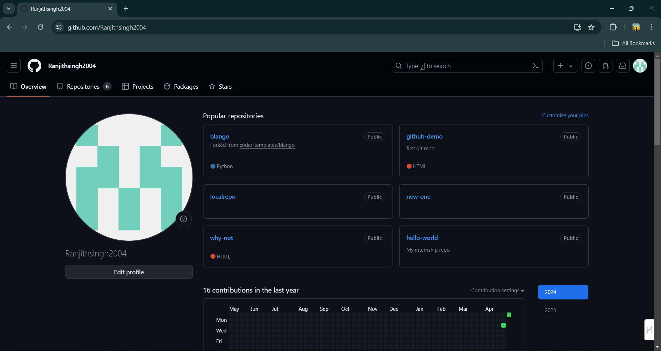

* Start a new repository named "hello-world". Make sure to initialize it with a README file.

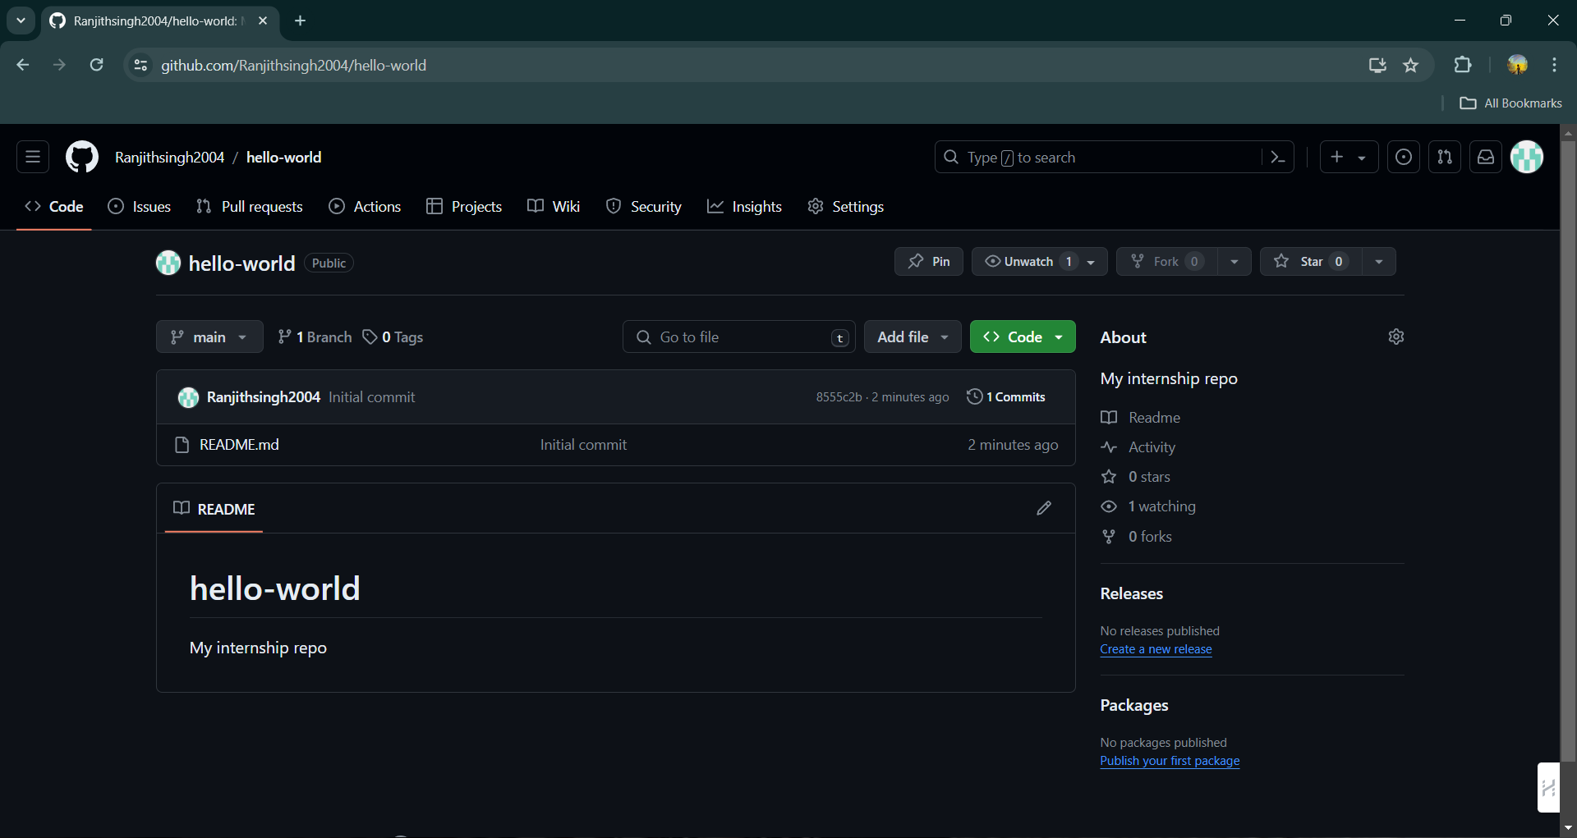

# GitHub Features Exploration

* In your "hello-world" repository, create a new branch named "feature".

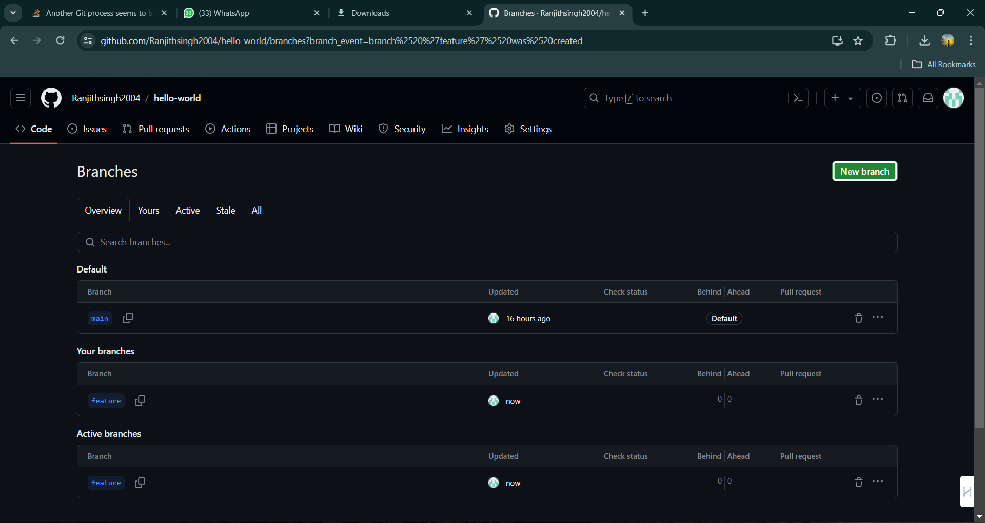

* Add a new file to this branch called "about_me.txt" that contains a few lines about what you are learning in this internship.

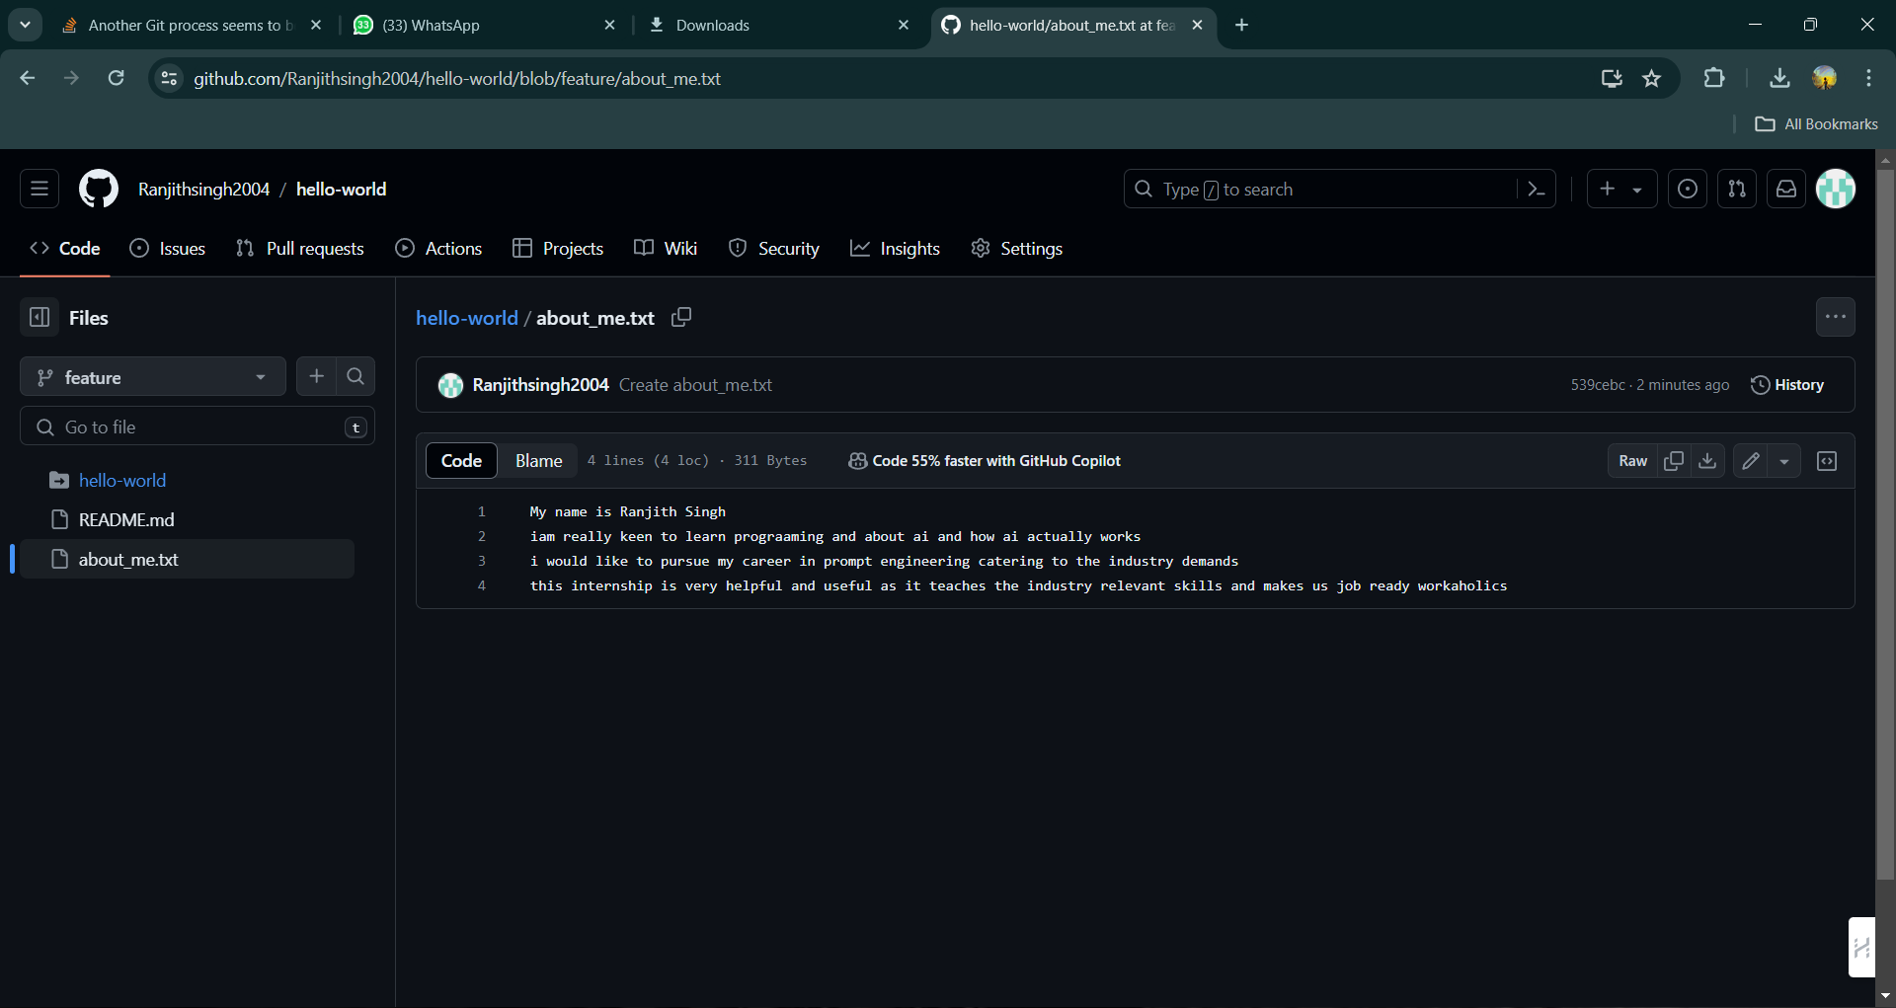

* Open an issue in your repository discussing one thing you found confusing or interesting about AIML.

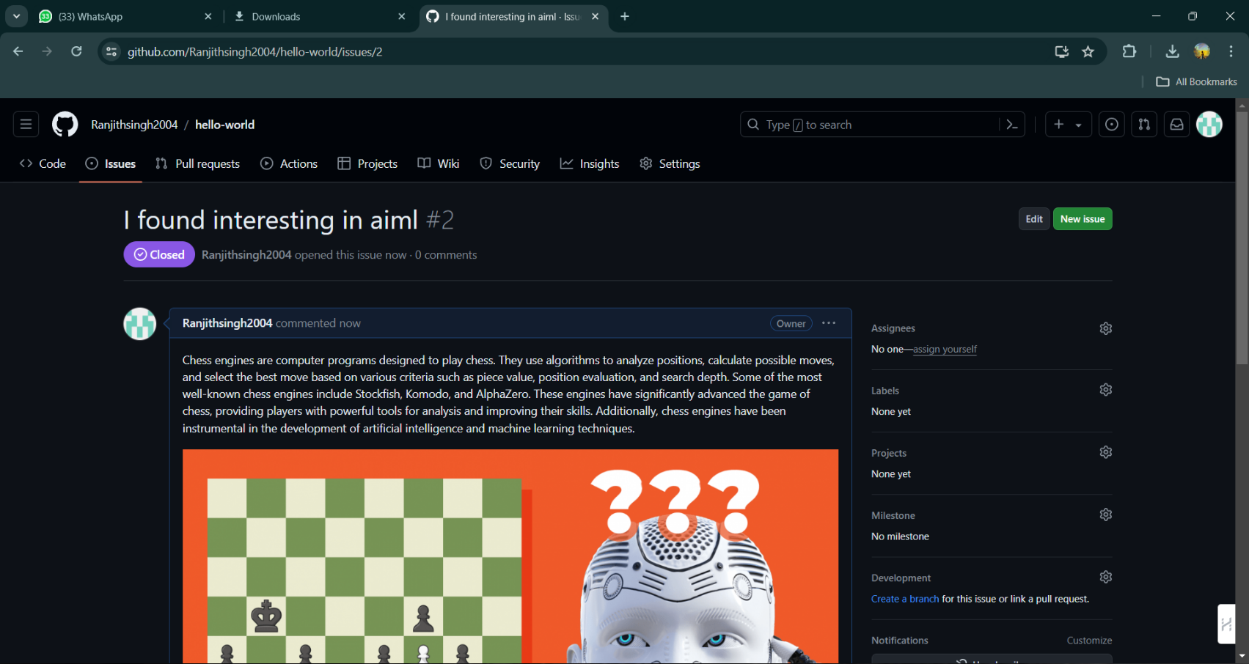

# Git Basics

* Clone your "hello-world" repository to your local machine.

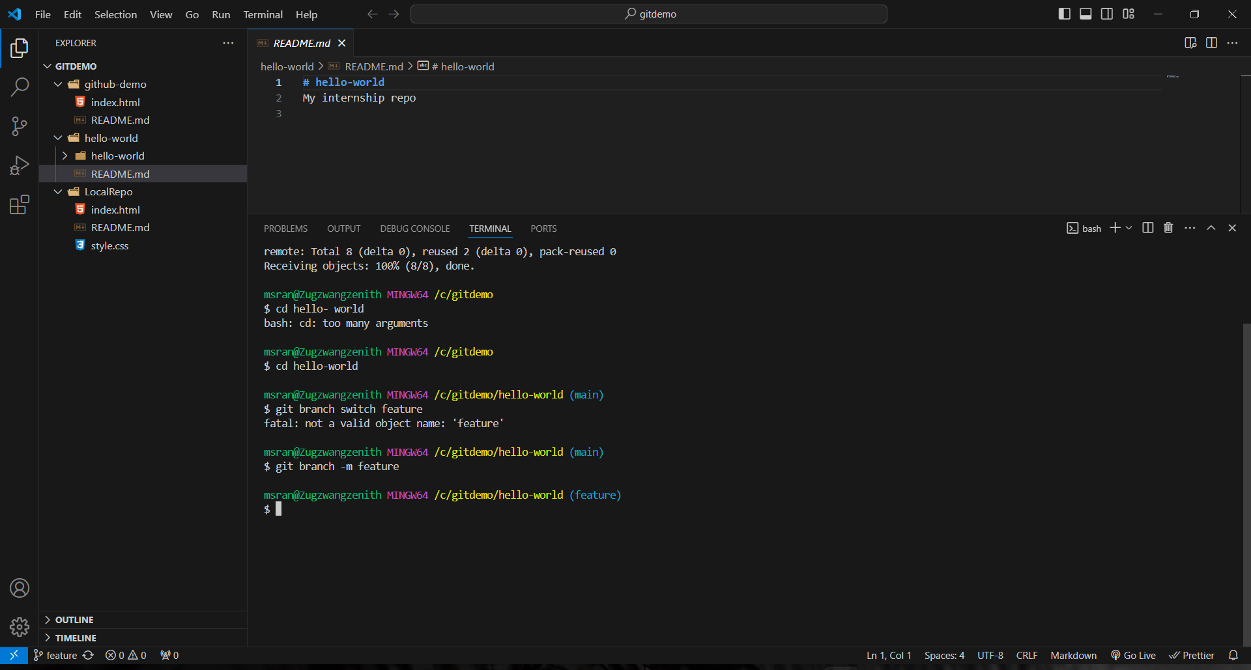

* Make a change locally in the "about_me.txt" file by adding more details or modifying the existing text.

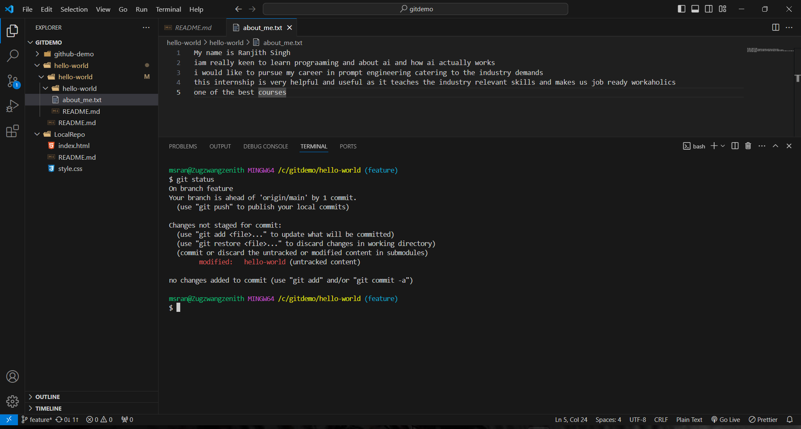

* Commit your changes locally and then push them to your "feature" branch on GitHub.

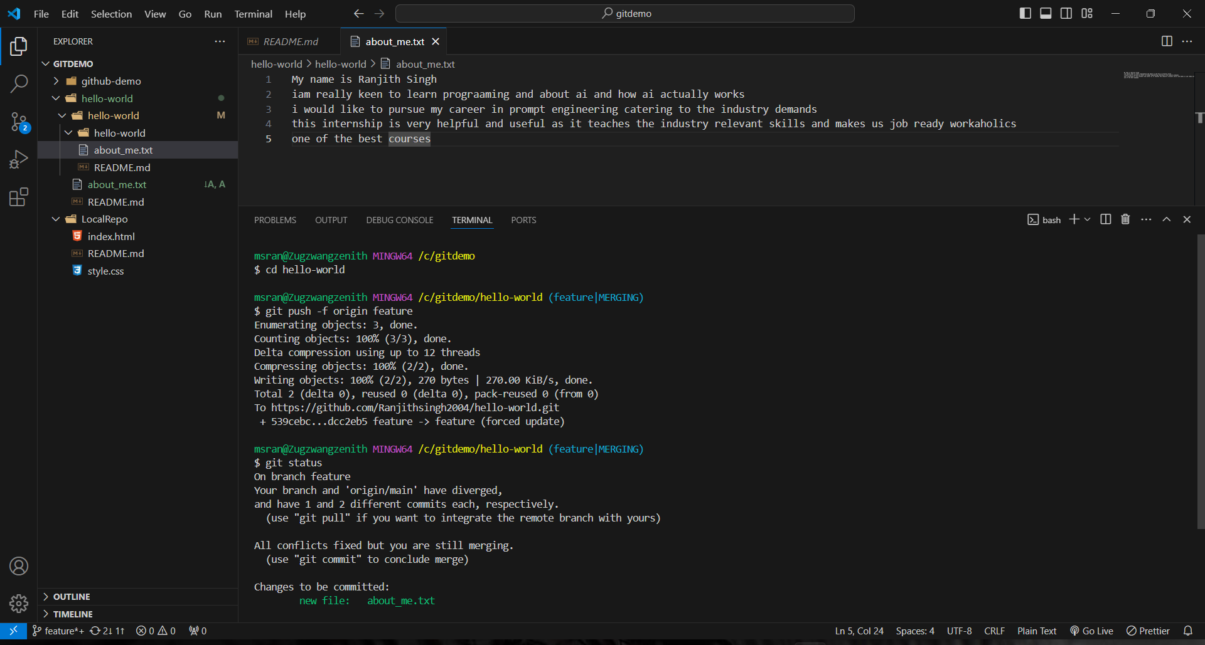

* Create a pull request to merge the changes from "feature" branch to the main branch on GitHub, and then merge it.

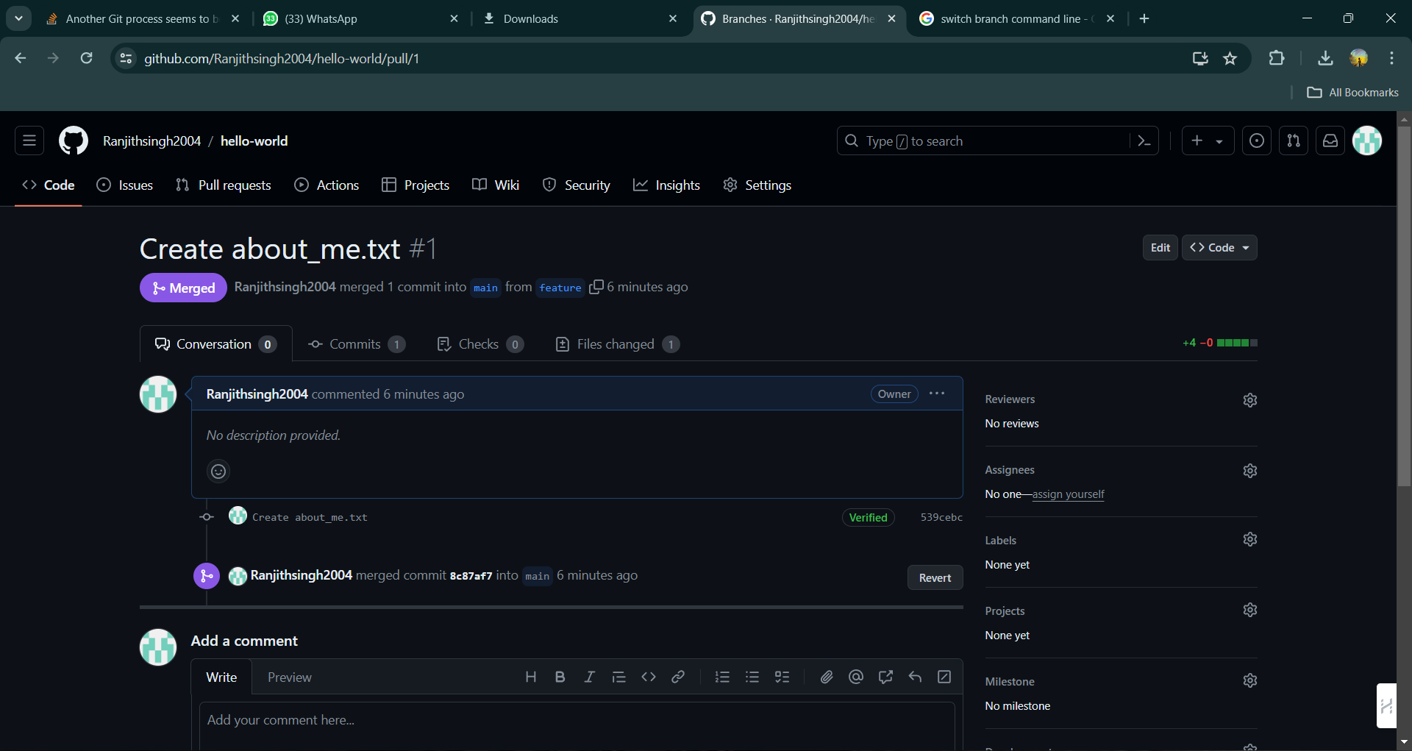

* Pull the latest changes from your GitHub repository to your local repository to ensure it is up to date.

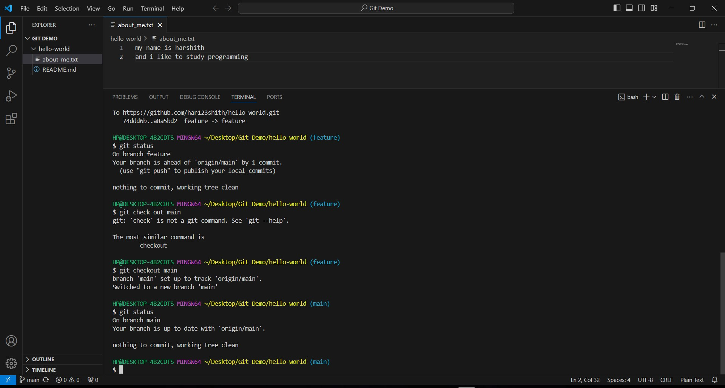

# Advanced Git Features

* 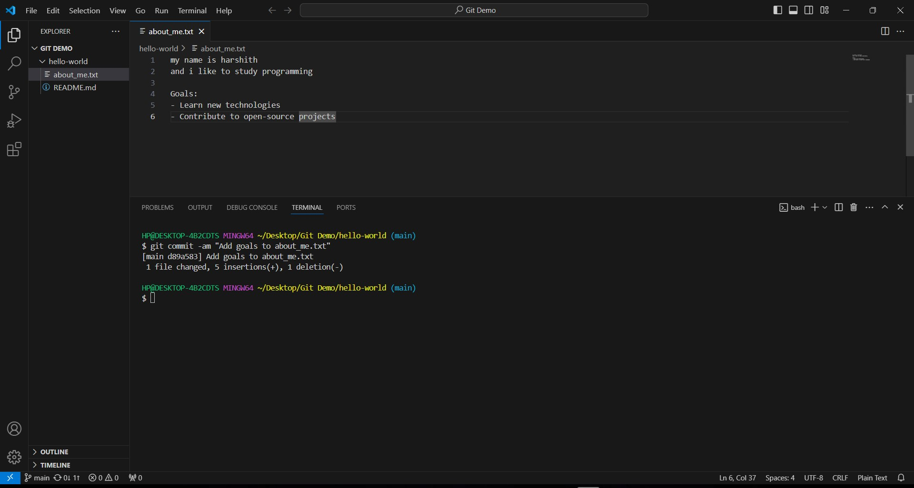In your local "hello-world" repository, prepare a minor release of your project. Incrementally update your "about_me.txt" to include a new section about your goals.
* Tag this new version of your project (e.g., v1.1) using Git tagging and push the tag to GitHub.

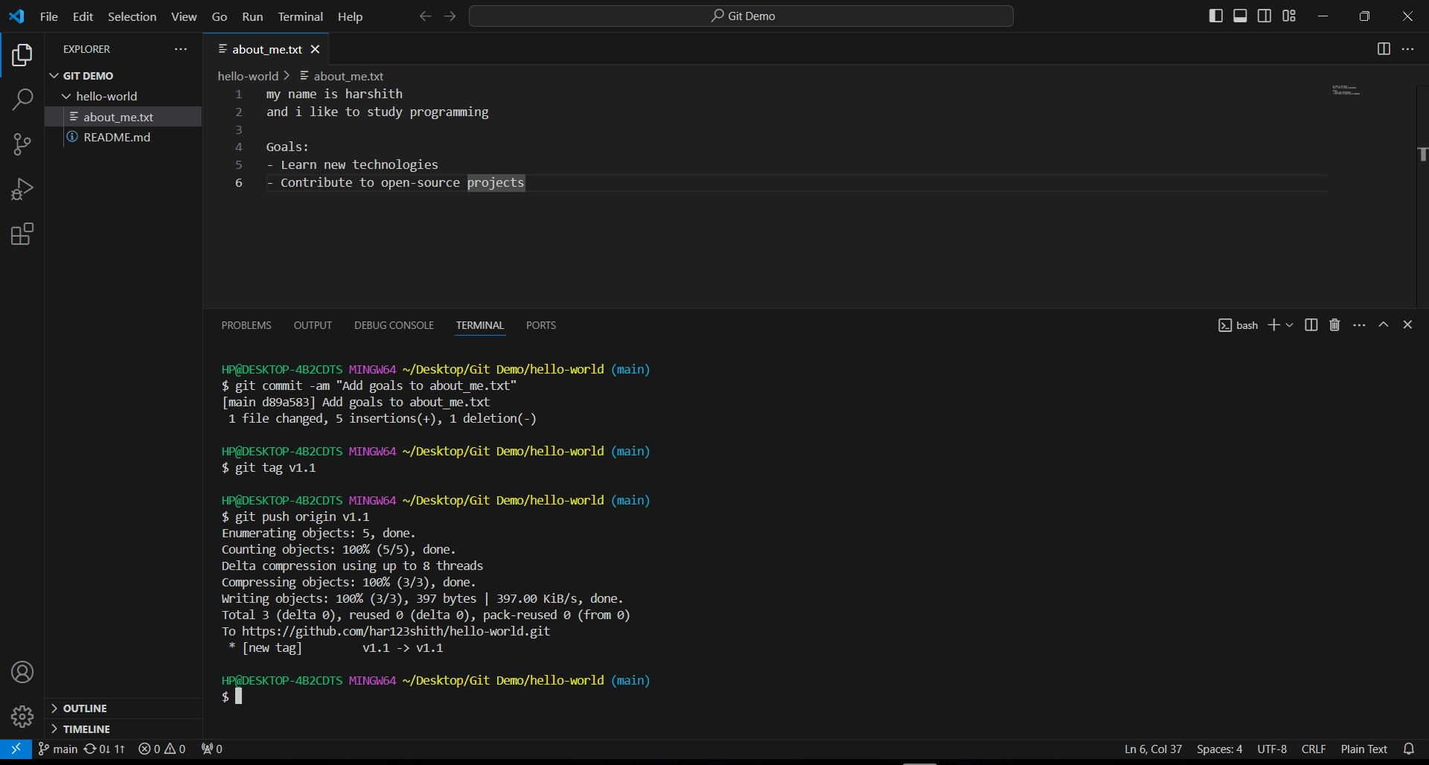

* Make some changes to "about_me.txt" but before committing, simulate a scenario where you need to switch branches to work on something else.

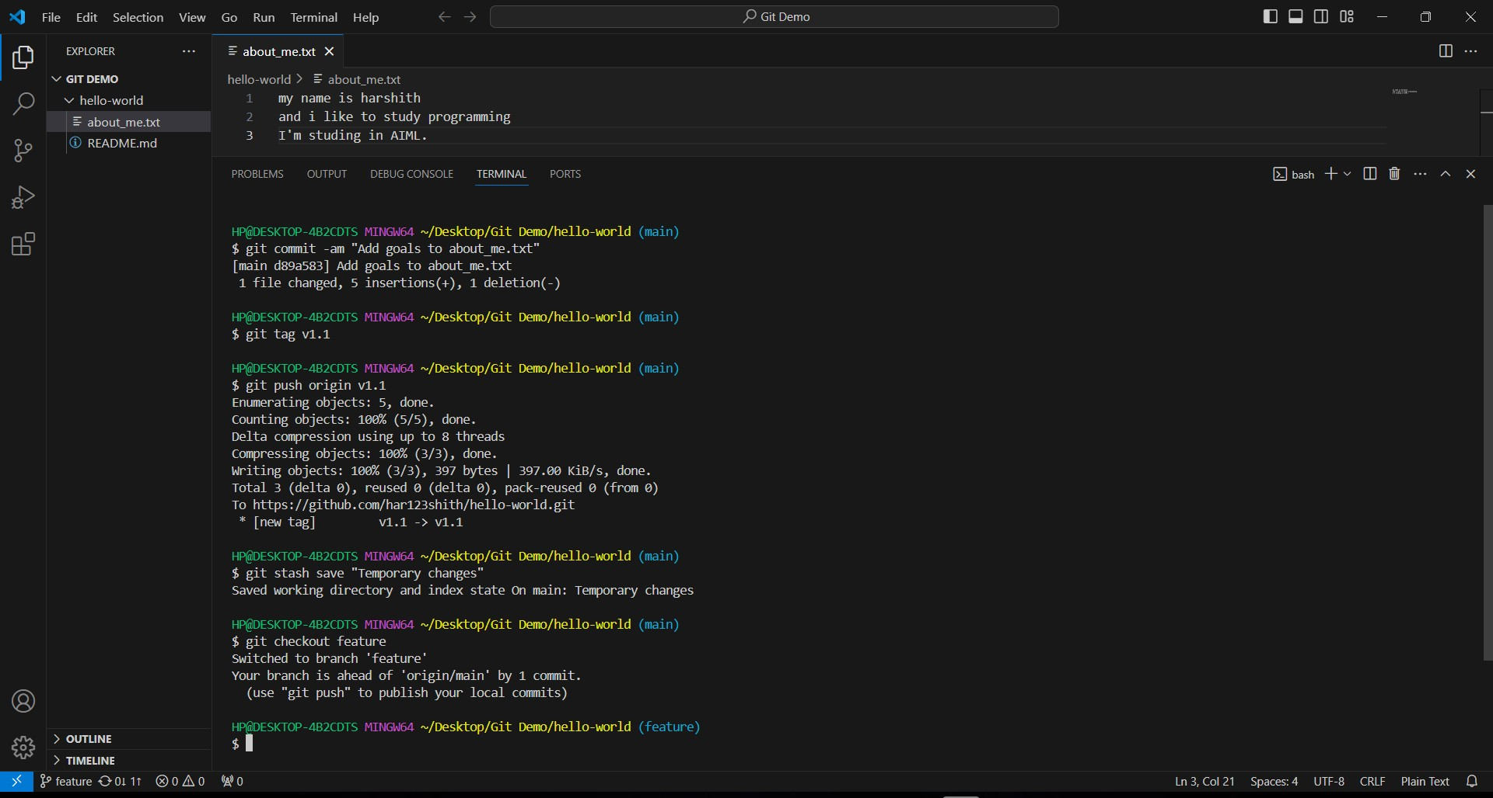

* Use git stash to save your uncommitted changes temporarily. Switch branches, then come back and reapply your stashed changes.

